**HUMAN BIOLOGY**

**Units 1 & 2**

**2018**



Name: _______________________________________________________

Teacher: ___________________________________________________

**Time allowed for this paper**

Reading time before commencing work: ten minutes

Working time: three hours

**Materials required/recommended for this paper**

***To be provided by the supervisor***

**Question/Answer Booklet One: Contains Sections One and three.**

**Multiple-choice answer sheet for Section One**

**Question/Answer Booklet Two: Contains Section Two**

***To be provided by the candidate***

* Standard items: pens (blue/black preferred), pencils (including coloured), sharpener,

correction fluid/tape, eraser, ruler, highlighters

* Special items: non-programmable calculators approved for use in this examination

**Important note to candidates**

No other items may be taken into the examination room. It is **your** responsibility to ensure that you do not have any unauthorised material. If you have any unauthorised material with you, hand it to the supervisor **before** reading any further.

**BOOKLET 2: SECTION 2**

**Structure of this paper**

|  |  |  |  |  |  |
| --- | --- | --- | --- | --- | --- |
| Section | Number of questions available | Number of questions to be attempted | Suggested working time (minutes) | Marks available | Percentage of examination |
| Section One  Multiple-choice | 30 | 30 | 40 | 30 | 30 |
| Section Two  Short answers | 9 | 9 | 90 | 105 | 50 |
| Section Three  Extended answers | 3 | 2 | 50 | 40 | 20 |
|  |  |  |  | **Total** | 100 |

**Instructions to candidates**

1. The rules for the conduct of the Western Australian examinations are detailed in the *Year 12 Information Handbook 2018*. Sitting this examination implies that you agree to abide by these rules.

2. Answer the questions according to the following instructions.

Section One: Answer all questions on the separate Multiple-choice answer sheet provided. For each question, shade the box to indicate your answer. Use only a blue or black pen to shade the boxes. If you make a mistake, place a cross through that square, then shade your new answer. Do not erase or use correction fluid/tape. Marks will not be deducted for incorrect answers. No marks will be given if more than one answer is completed for any question.

Section Two: Write your answers in **Question/Answer Booklet Two**. Wherever possible, confine your answers to the line spaces provided.

Section Three: Consists of three questions. You must answer two questions. Tick the box next to the question you are answering. Write your answers in **Question/Answer Booklet One**.

3. You must be careful to confine your answers to the specific questions asked and to follow any instructions that are specific to a particular question.

4. Supplementary pages for the use of planning/continuing your answer to a question have been provided at the end of this Question/Answer booklet. If you use these pages to continue an answer, indicate at the original answer where the answer is continued, i.e. give the page number.

5. Write all answers for **Section 2 in Booklet Two.** Write all answers for **Section 3 in Booklet One.**

**Section Two: Short answer 50% (105 Marks)**

This section has **nine (9)** questions. Answer **all** questions. Write your answers in the spaces provided.

Supplementary pages for the use of planning/continuing your answer to a question have been provided at the end of this Question/Answer booklet. If you use these pages to continue an answer, indicate at the original answer where the answer is continued, i.e. give the page number.

Suggested working time: 90 minutes.

**Question 31 (15 marks)**

An investigation was undertaken to determine the effect of temperature on the ability of freshly activated sperm to fertilise freshly extracted eggs. 5 mL samples of eggs were added to a sperm suspension and, after 5 minutes, the eggs were removed and incubated. Samples were then viewed under 200X magnification, with 300 eggs counted and the proportion of 4+ cell embryos recorded.

Concurrently, three replicates of 1mL samples of sperm were incubated for 2 hours at the same temperatures and standardised to a concentration of 107 sperm/mL-1. Sperm samples were transferred to a microscope slide and videotaped under 200X magnification. The velocity of the sperm was calculated using the same motion analysis system.

The results from the investigation are shown below.

|  |  |  |  |  |  |  |
| --- | --- | --- | --- | --- | --- | --- |
| **Temperature (℃)** | **15** | **20** | **25** | **30** | **35** | **40** |
| **Fertilisation Success (%)** | 19.4 | 21.6 | 58.5 | 87.2 | 39.4 | 23.6 |
| **Sperm Velocity (µm/sec-1)** | 45 | 50 | 89 | 150 | 45 | 38 |

1. Graph these results on the grid provided below.

(6 marks)

A spare grid can be found on page 26.

|  |  |  |  |  |  |  |  |  |  |  |  |  |
| --- | --- | --- | --- | --- | --- | --- | --- | --- | --- | --- | --- | --- |
|  |  |  |  |  |  |  |  |  |  |  |  |  |
|  |  |  |  |  |  |  |  |  |  |  |  |  |
|  |  |  |  |  |  |  |  |  |  |  |  |  |
|  |  |  |  |  |  |  |  |  |  |  |  |  |
|  |  |  |  |  |  |  |  |  |  |  |  |  |
|  |  |  |  |  |  |  |  |  |  |  |  |  |
|  |  |  |  |  |  |  |  |  |  |  |  |  |
|  |  |  |  |  |  |  |  |  |  |  |  |  |
|  |  |  |  |  |  |  |  |  |  |  |  |  |
|  |  |  |  |  |  |  |  |  |  |  |  |  |
|  |  |  |  |  |  |  |  |  |  |  |  |  |
|  |  |  |  |  |  |  |  |  |  |  |  |  |
|  |  |  |  |  |  |  |  |  |  |  |  |  |
|  |  |  |  |  |  |  |  |  |  |  |  |  |

1. Identify **two** variables **not** indicated in the information for the fertilisation success investigation that needed to be maintained across all temperatures to ensure a fair test was conducted. (2 marks)

___________________________________________________________________

___________________________________________________________________

___________________________________________________________________

1. For **one** of the variables identified in part (b), state why it needed to be controlled.

(1 mark)

___________________________________________________________________

___________________________________________________________________

___________________________________________________________________

1. Suggest what may have caused the observed effect of increased fertilisation success. (3 marks)

___________________________________________________________________

___________________________________________________________________

___________________________________________________________________

___________________________________________________________________

___________________________________________________________________

___________________________________________________________________

1. Explain what may have caused the drastic drop in sperm velocity after 30℃. (3 marks)

___________________________________________________________________

___________________________________________________________________

___________________________________________________________________

___________________________________________________________________

___________________________________________________________________

___________________________________________________________________

**Question 32 (10 marks)**

A married couple, intending on starting their own family, were advised to attend a local genetic counselling clinic to discuss the risks of producing offspring with phenylketonuria (PKU), which is present in the mother’s family.

1. Suggest an explanation the genetic counsellor may have given to explain the relationship between genes and chromosomes. (2 marks)

___________________________________________________________________

___________________________________________________________________

___________________________________________________________________

___________________________________________________________________

1. Suggest a reason as to why the genetic counsellor would create a pedigree chart for this disease. (1 mark)

___________________________________________________________________

___________________________________________________________________

Upon receiving this advice, the couple then attended a fertility clinic to get information on how to increase their chances of pregnancy. The clinician described the structure and function of the human reproductive system, and explained the reproductive cycles.

1. State the differences between the female and male gametes concerning their size, structure and relative number. (3 marks)

___________________________________________________________________

___________________________________________________________________

___________________________________________________________________

___________________________________________________________________

___________________________________________________________________

___________________________________________________________________

1. Describe one factor that the couple could monitor that could be used to increase the couple’s chances of falling pregnant. (2 marks)

___________________________________________________________________

___________________________________________________________________

___________________________________________________________________

___________________________________________________________________

1. (i) Unfortunately the couple struggled to fall pregnant. Identify **one** Assisted

Reproductive Technology (ART) that the couple could use.

(1 mark)

________________________________________________________________

(ii) State **one** common complication associated with the ART identified in part (e)(i) above.

(1 mark)

____________________________________________________________________________________________________________________________________________

**Question 33 (12 marks)**

For many hundreds of years, experiments with blood transfusions have been undertaken. However, it was in 1901, when Karl Landsteiner discovered human blood groups, that they became safer.

1. State **one** disease that would require a blood transfusion.

(1 mark)

___________________________________________________________________

1. Explain why it is important to determine the blood groups of both the recipient and donor in blood transfusions. (4 marks)

___________________________________________________________________

___________________________________________________________________

___________________________________________________________________

___________________________________________________________________

___________________________________________________________________

___________________________________________________________________

___________________________________________________________________

___________________________________________________________________

1. Describe how ABO blood groups are inherited. (3 marks)

___________________________________________________________________

___________________________________________________________________

___________________________________________________________________

___________________________________________________________________

___________________________________________________________________

___________________________________________________________________

1. Using a Punnett square, explain if it is possible for an O-type child to be born to a B-type father and AB-type mother. (4 marks)

___________________________________________________________________

___________________________________________________________________

___________________________________________________________________

___________________________________________________________________

___________________________________________________________________

___________________________________________________________________

___________________________________________________________________

___________________________________________________________________

**Question 34 (12 marks)**

1. Muscles work in pairs to provide the skeletal system with motion. Explain why synergists are important in producing movement. (3 marks)

___________________________________________________________________

___________________________________________________________________

___________________________________________________________________

___________________________________________________________________

___________________________________________________________________

___________________________________________________________________

The diagrams below show one sarcomere in its fully relaxed state and when it is contracted fully.

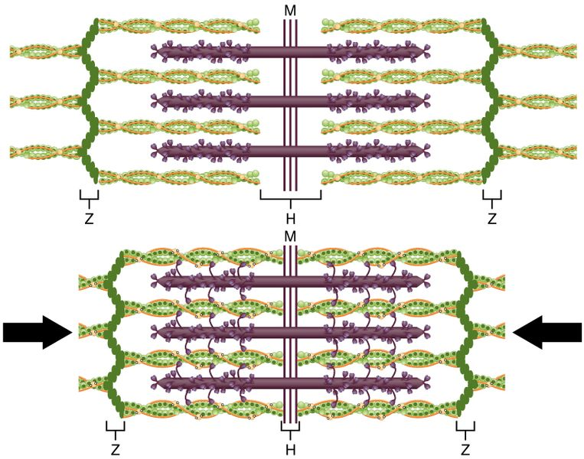

1. When a sarcomere contracts, the myosin filaments pull the actin filaments towards the M-line. Explain how this movement occurs. (4 marks)

___________________________________________________________________

___________________________________________________________________

___________________________________________________________________

___________________________________________________________________

___________________________________________________________________

___________________________________________________________________

1. There are two types of bone found in the human body. Name these types of bone and describe **two** structural differences between the two.

(4 marks)

___________________________________________________________________

___________________________________________________________________

___________________________________________________________________

___________________________________________________________________

___________________________________________________________________

___________________________________________________________________

___________________________________________________________________

___________________________________________________________________

1. Suggest why a ball-and-socket joint at the knee would create problems for upright walking. (1 mark)

___________________________________________________________________

___________________________________________________________________

**Question 35 (12 marks)**

1. The Atkins Diet is based on high protein foods.
2. Briefly describe what happens to these proteins after the food reaches the stomach and then enters the small intestine. (4 marks)

________________________________________________________________________________________________________________________________________________________________________________________________________________________________________________________________________________________________________________________________________________________________________________________________________________________________________________________________________________________________________________________________________________________________________________

1. State the name given to the type of digestion that would have occurred in the mouth prior to swallowing. (1 mark)

________________________________________________________________

1. Suggest a reason why high protein diets are recommended for weight loss.

(1 mark)

____________________________________________________________________________________________________________________________________________

1. Type 1 Diabetes is a genetic disorder that inhibits an individual from taking up glucose into their cells. Blood glucose monitoring is therefore very important for individuals with Type 1 Diabetes.
2. A glucose biosensor uses the enzyme glucose oxidase. Using your understanding of enzymes, briefly explain why the biosensor is specific for glucose. (2 marks)

________________________________________________________________________________________________________________________________________________________________________________________________________________________________________________________________________________________

1. State the names and locations of the steps involved in the complete breakdown of glucose within the cell. (3 marks)

____________________________________________________________________________________________________________________________________________________________________________________________________________________________________________________________________________________________________________________________________________________________________________________________________________________________________

1. Identify **one** product that differs between aerobic and anaerobic respiration in human cells. (1 mark)

________________________________________________________________

**Question 36 (8 marks)**

An investigation on the effect of physical activity on respiration rate was undertaken. Immediately after completing an activity, each individual breathed into a container of pH indicator solution. The time it took for the pH indicator to change from blue to red was recorded.

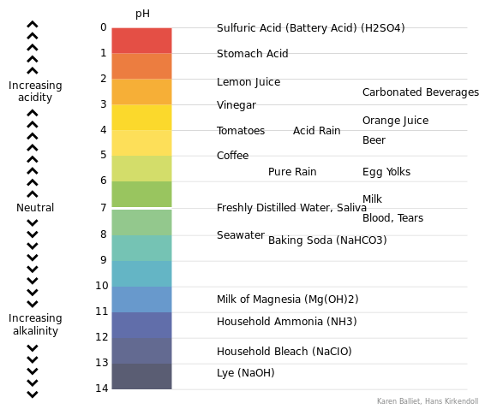

Purple Dark Blue Blue Green Yellow Orange Red

1. Identify the gas that would have been present in larger amounts after the activity, and explain why its presence would have caused the change in colour. (2 marks)

________________________________________________________________________________________________________________________________________________________________________________________________________________________________________________________________________________________

Whilst performing one of the activities, one of the individuals fell over and cut their knee.

1. (i) State which two formed elements of the blood would expect to increase in concentration following this injury, and explain why this would have occurred. (4 marks)

________________________________________________________________________________________________________________________________________________________________________________________________________________________________________________________________________________________________________________________________________________________________________________________________________________________________________________________________________________________________________________________________________________________________________________

(ii) Name and describe the type of tissue that blood is categorised as. (2 marks)

________________________________________________________________________________________________________________________________________________________________________________________________________________________________________________________________________________________

**Question 37 (11 marks)**

1. The following diagrams represent a selection of the five (5) different stages of mitosis.

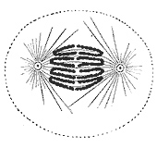 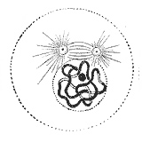 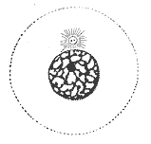

A B C

1. List the diagrams (A, B, C) in the correct order for the process of mitosis. (1 mark)

________________________________________________________________

1. Identify the missing stages and draw diagrams to show what would be occurring in each of the missing stages. (4 marks)
2. During the synthesis stage of mitosis, the DNA within a cell is replicated to allow for the production of identical daughter cells.

State the role of the following enzymes in the process of DNA replication.

(3 marks)

1. Helicase

_____________________________________________________________________________________________________________________________________

1. DNA Polymerase

_____________________________________________________________________________________________________________________________________

1. DNA Ligase ______________________________________________________________________________________________________________________________________

Occasionally cells can become abnormal, invading and damaging the tissues of the body. These diseases can be diagnosed as cancer.

1. Describe how cancer develops and suggest one way it can spread throughout the body (metastasise). (3 marks)

______________________________________________________________________________________________________________________________________________________________________________________________________________________________________________________________________________________________________________________________________________________________________________________________________________________________________________________

**Question 38 (13 marks)**

1. A sample of tissue was extracted from a crime scene. DNA profiling was undertaken and the respective banding patterns produced. These are shown in the diagram below.

|  |  |  |  |  |  |  |
| --- | --- | --- | --- | --- | --- | --- |
|  |  |  |  |  |  |  |
|  |  |  |  |  |  |  |
|  |  |  |  |  |  |  |
|  |  |  |  |  |  |  |
|  |  |  |  |  |  |  |
|  |  |  |  |  |  |  |
|  |  |  |  |  |  |  |
| Victim |  | Suspect 1 |  | Sample |  | Suspect 2 |

1. Identify which suspect was most likely the perpetrator of this crime.

(1 mark)

________________________________________________________________

1. Explain how you arrived at your answer in part (a)(i). (1 mark)

___________________________________________________________________________________________________________________________________________

DNA profiling utilises the biotechnology of Polymerase Chain Reaction (PCR). PCR mimics the steps of DNA replication.

1. Identify **three** structural properties of DNA that allow it to be replicated.

(3 marks)

______________________________________________________________________________________________________________________________________________________________________________________________________________________________________________________________________________________________________________________________________________________________________________________________________________________________________________________

1. DNA profiling can also be used for the screening of embryonic stem cells. Discuss an ethical issue that may arise in stem cell research for people with religious beliefs.

(2 marks)

____________________________________________________________________________________________________________________________________________________________________________________________________________________________________________________________________________________________________

1. Where are embryonic stem cells harvested from? (2 marks)

__________________________________________________________________________________________________________________________________________________

Below is a pedigree of a human skin disease that was created by using the information attained from DNA profiling of a family.

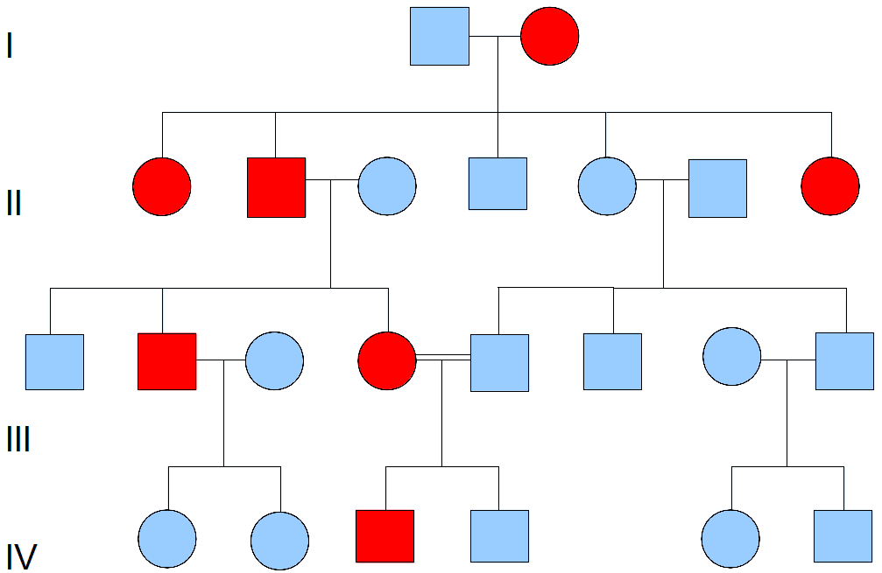

1. (i) Identify the relationship identified by the double horizontal lines connecting

individuals III-4 and III-5. (1 mark)

________________________________________________________________

(ii) Is this disease X-linked or Autosomal? Use individual III-2 to justify your answer. (3 marks)

________________________________________________________________________________________________________________________________________________________________________________________________________________________________________________________________________________________________________________________________________________________________________________________________

**Question 39 (12 marks)**

The female reproductive system is designed to both produce gametes and provide for the development of an embryo and foetus.

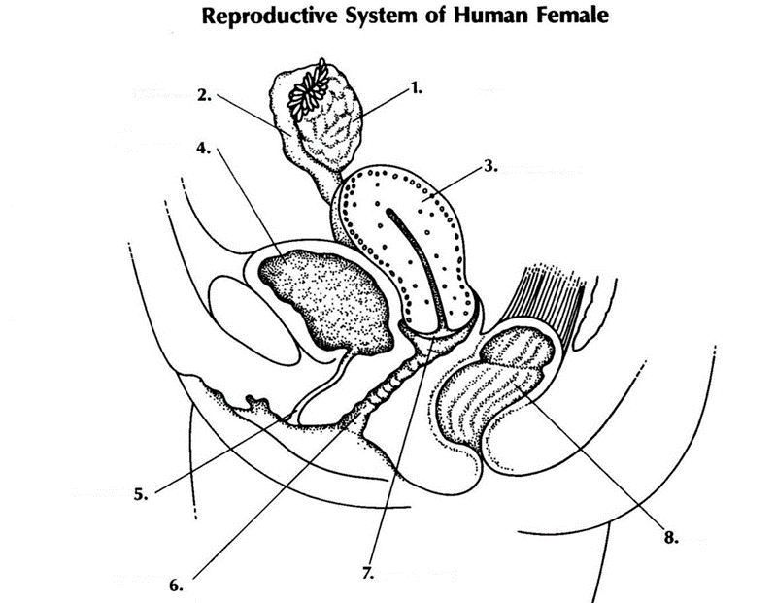

1. Identify the structures identified at position: (2 marks)

2: ___________________________________________

7: ___________________________________________

1. State **one** function of the organ labelled by the number 6. (1 mark)

__________________________________________________________________________________________________________________________________________________

1. In 90% of births, the foetus’s head is facing downward. Describe **one** reason why it is better for the foetus to be in this position. (2 marks)

____________________________________________________________________________________________________________________________________________________________________________________________________________________________________________________________________________________________________

1. Explain why a large number of sperm are required for fertilisation.

(3 marks)

__________________________________________________________________________________________________________________________________________________________________________________________________________________________________________________________________________________________________________________________________________________________________________________________________________________

1. Describe **one** hormonal contraception method for women that could be used to prevent fertilisation. Identify **one** risk and **one** benefit of this method as a contraceptive. (4 marks)

________________________________________________________________________________________________________________________________________________________________________________________________________________________________________________________________________________________________________________________________________________________________________________________________________________________________________________________________________________________________________________________________________________________________________________________________________

***END OF SECTION 2***

Question number: ________________

_____________________________________________________________________________________________________________________________________________________________________________________________________________________________________________________________________________________________________________________________________________________________________________________________________________________________________________________________________________________________________________________________________________________________________________________________________________________________________________________________________________________________________________________________________________________________________________________________________________________________________________________________________________________________________________________________________________________________________________________________________________________________________________________________________________________________________________________________________________________________________________________________________________________________________________________________________________________________________________________________________________________________________________________________________________________________________________________________________________________________________________________________________________________________________________________________________________________________________________________________________________________________________________________________________________________________________________________________________________________________________________________________________________________________________________________________________________________________________________________________________________________________________________________________________________________________________________________________________________________________________________________________________________________________________________________________________________________________________________________________________________________________________________________________________________________________________________________________________________________________________________________________________________________________________________________________________________________________________________________________________________________________________________________________________________________________________________________________________________________________________________________________________________

Question number: ________________

_____________________________________________________________________________________________________________________________________________________________________________________________________________________________________________________________________________________________________________________________________________________________________________________________________________________________________________________________________________________________________________________________________________________________________________________________________________________________________________________________________________________________________________________________________________________________________________________________________________________________________________________________________________________________________________________________________________________________________________________________________________________________________________________________________________________________________________________________________________________________________________________________________________________________________________________________________________________________________________________________________________________________________________________________________________________________________________________________________________________________________________________________________________________________________________________________________________________________________________________________________________________________________________________________________________________________________________________________________________________________________________________________________________________________________________________________________________________________________________________________________________________________________________________________________________________________________________________________________________________________________________________________________________________________________________________________________________________________________________________________________________________________________________________________________________________________________________________________________________________________________________________________________________________________________________________________________________________________________________________________________________________________________________________________________________________________________________________________________________________________________________________________________________

Question number: ________________

_____________________________________________________________________________________________________________________________________________________________________________________________________________________________________________________________________________________________________________________________________________________________________________________________________________________________________________________________________________________________________________________________________________________________________________________________________________________________________________________________________________________________________________________________________________________________________________________________________________________________________________________________________________________________________________________________________________________________________________________________________________________________________________________________________________________________________________________________________________________________________________________________________________________________________________________________________________________________________________________________________________________________________________________________________________________________________________________________________________________________________________________________________________________________________________________________________________________________________________________________________________________________________________________________________________________________________________________________________________________________________________________________________________________________________________________________________________________________________________________________________________________________________________________________________________________________________________________________________________________________________________________________________________________________________________________________________________________________________________________________________________________________________________________________________________________________________________________________________________________________________________________________________________________________________________________________________________________________________________________________________________________________________________________________________________________________________________________________________________________________________________________________________________

Spare Graph Paper for Question 32

